**19) Develop a user interface prototype for an Android application using Figma.**

**Aim:**

To Develop a user interface prototype for an Android application using Figma.

**Procedure:**

1. Create a file
2. Add The First Frame
3. Add Shapes
4. Add Text
5. Create The Second Frame
6. Add Prototyping

**Step By Step Procedure :**

**Interface Of Experiment:**

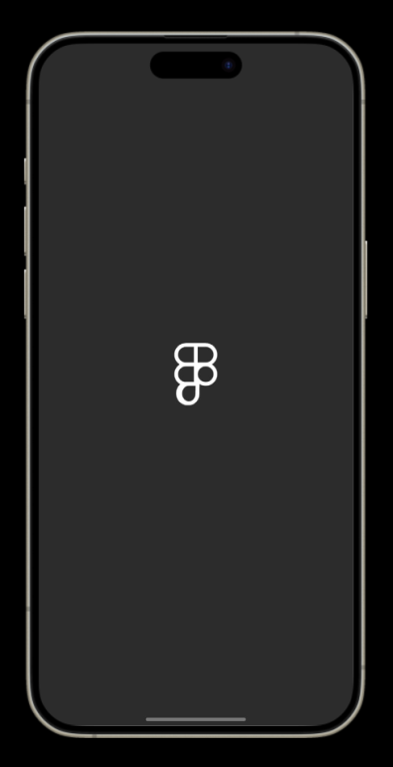

**Next Page:**

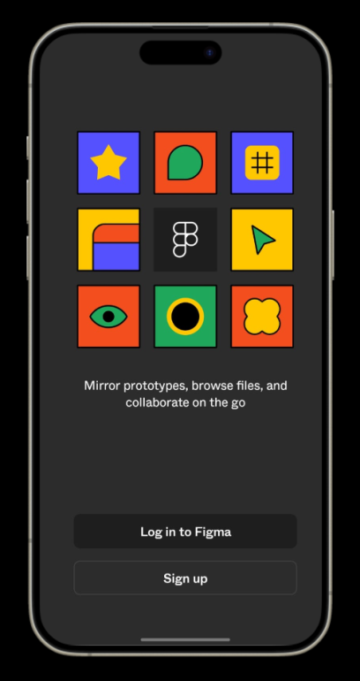

**Login And Signup Page:**

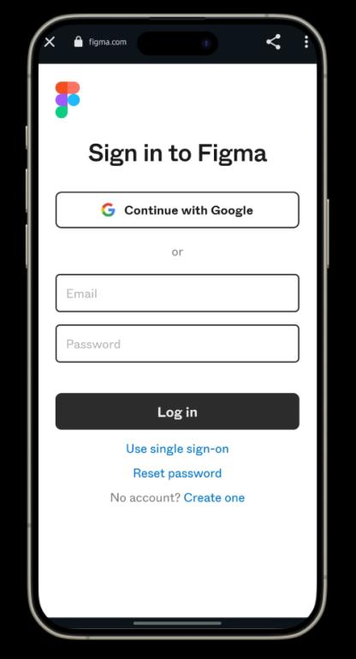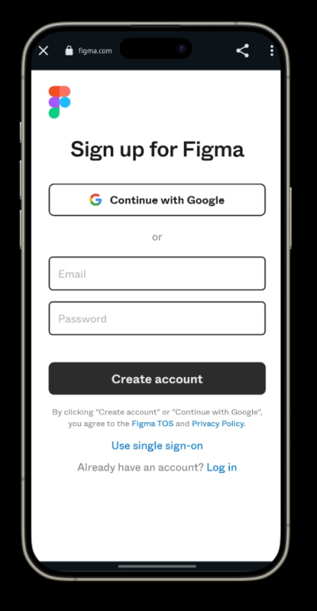

**Final Step:**

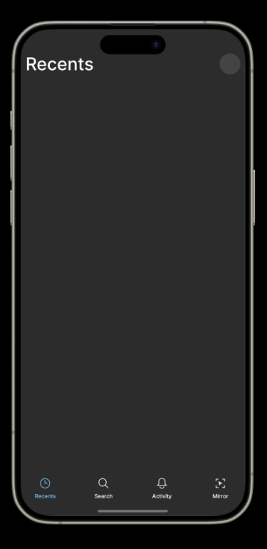

**Prototype:**

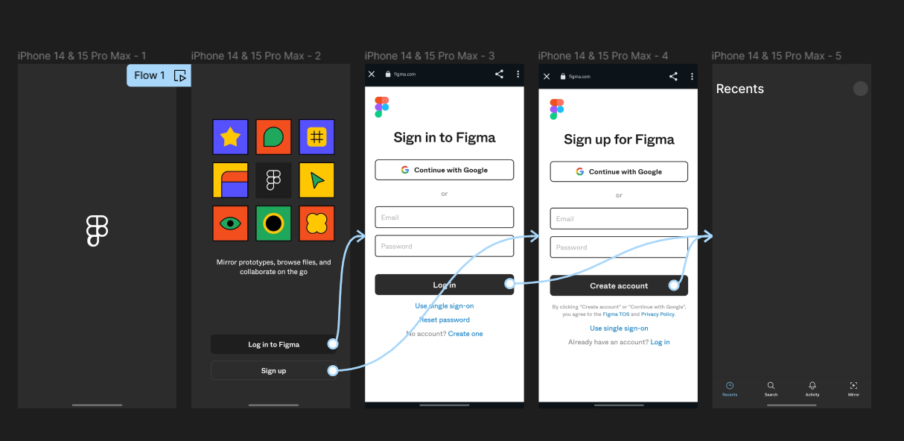

**Result:**

Hence the Develop a user interface prototype for an Android application created and executed successfully